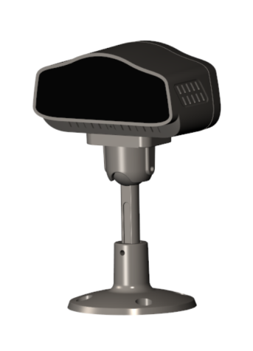

Features：
·SOI H65 CMOS Image Sensor
· Full HD-720P
· 2D-NR

Parameter
Specifications | Model | TL-DMS-S2
Specifications | Name | DMS Camera
Specifications | Sensor | H65
Specifications | Image Sensor | 130W CMOS Sensor
Specifications | Image color | Black -White
Specifications | Focal Length | 3.6mm
Specifications | IR | NA
Specifications | View Angle | D=85° H=60° V=53°
Specifications | WDR | Yes
Specifications | Signal Type | PAL
Specifications | FPS | 25fps
Properties | Temperature | -25℃~75℃
Properties | Humidity | ≤ 90 %
Properties | Voltage | 12V DC
Properties | Rated power | 1.25W
Properties | Cable Length | Aviation connector, 2.5m

Pin Feet Definition
PIN | Name | Pin Type | Function
1 | VCC | Power | 12V
2 | GND | Power | Cathode
3 | NA | NA | NA
4 | VIDEO | AHD | Video


